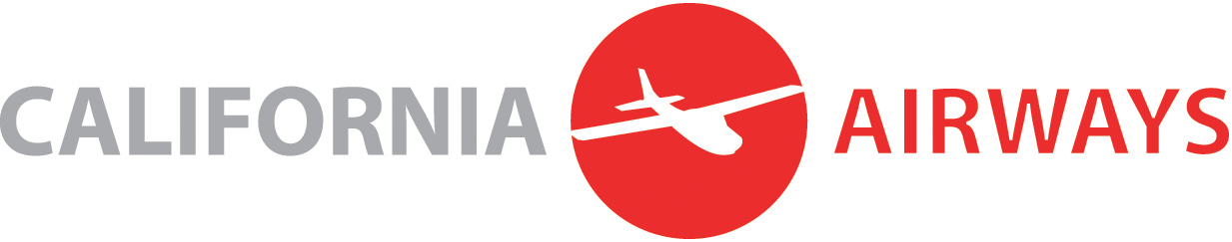

PHASE CHECK FORM (PRE-SOLO-CROSS-COUNTRY)

ALL student pilots at California Airways must satisfactorily complete a phase check with an authorized California Airways instructor, prior to conducting their first solo cross-country flight. This phase check form must be completed by the check instructor and a copy must be kept on file at California Airways.

Student Name: _________________ Date: _______________
Flight Hours (Dual): _________________ Flight Hours (Solo): _______________
Aircraft Make & Model: _________________ Recommending CFI: _______________

 | SATISFACTORY | UNSATISFACTORY | REMARKS
Sectional chart and A/FD interpretation
Airspace
Regulations
Weather Briefings
Weight and Balance
Flight planning
Performance data
Flight plan filing/ opening/ closing
Navigation –- pilotage and dead reckoning
Navigation –- VOR, GPS
(if equipped)
Radio procedures/ ATC
Short-field operations
Soft-field operations
Uncontrolled airport operations
Flight by instrument references
Normal takeoff/landing
Inflight diversions
Inflight E6B calculations
Emergencies: Lost procedures
Emergencies: partial and total power losses (MUST be continued to a successful LANDING)
Emergencies:
Communication failures
Emergencies:
Electrical failures

Overall result: Satisfactory or Unsatisfactory? _________________________
Phase Check Instructor’s Signature: _________________________
Date of Phase Check: _________________________

